There are two sections to this document.
- The first offers a variety of ways for educators to reach out and connect with families in real-time.
- The second provides a number of get-ready-for-Pesah activities that are relatively engaging and do not take a lot of complicated equipment or supplies. They have been written in language directed to parents - teachers and education directors can choose what will be of most interest to their families and copy-and-paste them into personal emails to parents, a few at a time or all at once.

OFFER AT-HOME ACTIVITIES FOR CHILDREN AND FAMILIES
This list was written using language that enables teachers to
cut and paste ideas into their emails to parents and children.

FOR READERS AND WRITERS
- Read books.
Read aloud or listen to Pesah-themed books that help your child learn about this amazing holiday! For older children make it a marathon – read until all are done!
  - You might have some PJ Library books already in your home.
  - Feel free to listen to some books that have been recorded: https://pjlibrary.org/listen
  - Use puppets or make-shift costumes and act out the storylines! Older children can do this without guidance, putting on a show for the others in the family.
  - Children who can read might curl up and read to your dog or cat.

- A seder reading.
  - Use the bazillion resources in Haggadot.com to create a new addition to your seder – it might be one reading or it could be something bigger.

- Letter writing.
Write to a family member (perhaps the oldest or the one who lives farthest away) and ask for some early seder memories. The contacted relative should be offered the choice of writing back or setting up a Skype/Facetime call.

- Write your own Pesah story.
  - Make a plan
  - Type each page and add illustrations, photos or clip art.
  - Bind the book https://babbledabbledo.com/design-for-kids-recycled-handmade-journals/
  - Read and enjoy!

FOR “MOVERS”
- What’cha going to grab?
Supplies: One paper or plastic bag per person, a way to keep time
  - Moses is getting ready to lead the Jews out of Egypt! What are you going to grab to take with you?
  - Set the timer (5 minutes) and tell players they need to grab what they think is most important to take with them. No limit on the number of items, as long as they fit in the bag!
  - After the timer “dings!” spend time sharing what everyone chose and why.

- Overnight in the desert
Supplies: Sheets, blankets, pillows, beads, cooking pots, etc.
  - Everyone has escaped with Moses but it’s now time to rest for the night.
  - Using the supplies you’ve provided, as well as other items they find around the house, work together to to create a sukkah – a temporary shelter.
  - Optional: Dress up in Egyptian clothing (a towel around one’s waist) or desert garb (robe, along with a towel placed on one’s head). Offer a matzah snack.
  - Leave up the desert home for a bit so your child can play!

- Pesah Scavenger Hunt
  - Offer a page of items to find such as this:
    - At the seder, we are supposed to recline in the spirit of free people. What would make your reclining more comfortable?
    - Karpas are green vegetables that remind us of springtime. Find one thing we could eat as karpas.
    - We eat unleavened bread on Pesah . Find a box of “unleavened bread” (do not open it!)
    - List five complaints you thing the Jews would have moaned about in the desert.
    - NEED MORE. Is there a staff member who might have the time to build the list? A teacher?

FOR ARTISTS AND MUSICIANS
- Sidewalk chalk art
Supplies: Sidewalk chalk
  - Read some books or view videos about the exodus from Egypt
  - Then, illustrate some great pictures on a very large “canvas!”

- Create a meme or GIF
  - Do an internet search for Passover (or Pesah ) memes or GIFS, then create your own.

- Make a video.
Use stop-motion animation to tell part of the story of the exodus from Egypt, or something seder-related (funny or serious).
Supplies: A stop motion app on your smartphone or tablet, clay or other supplies.
  - For a quick explanation of how to make stop-motion animation, check: https://tinkerlab.com/easy-stop-motion-animation-kids/
If you like more detailed instructions, check this link: https://tinyurl.com/qpdktdw
  - Spend some time, adult-and-child, learning about the content your child wants to animate.
    - Read a story
    - View a video
    - Page through a haggadah
  - Create a storyboard, basically an outline of what will happen on the screen
  - Help your child learn to move the objects about ¼ of an inch at a time, taking a photo of each one using the smartphone app. Most people need a trial run to see how things look as they are moved.
  - Share the final creation!

Create a TickTok with a Pesah theme. [FOR OLDER CHILDREN]

Use your imagination and skills to make any other kind of video

- Rock out!
Put on Pesah music and sing or dance! Turn some cooking pots upside down and bang away to the beat!
  - General fun songs are here: https://open.spotify.com/playlist/161aqvPKONZYKZZK60uyvs
  - Pesah seder tunes are here: https://open.spotify.com/playlist/3bOoDZH3BabssZmtw7eFfX
- Lots of fun and serious Pesah music here:
https://www.youtube.com/results?search_query=passover+children%27s+songs

FOR MOVIE-BUFFS AND GAMERS
- Pesah -themed Family Movie Night - Grab a snack, put your feet up and watch together.
ARTICLE: 5 Passover Movies to Watch With Your Kids https://www.kveller.com/article/passover-movies/

INFORMATIVE VIDEOS:
For young children:
- Book read-alouds:
  - Is it Passover Yet, by Chris Barash https://youtu.be/q-V_GyVDRgw
  - What is Passover, by Harriet Ziefert: https://youtu.be/Z9lSBIa0KYE
- Sing along videos (BimBam): https://www.bimbam.com/?s=passover+sing+along
- The Passover Shaboom Special: What’s Different about Tonight (BimBam) https://youtu.be/BUv0BTdUNPo

For older children through adults:
- Passover Seder, What to Expect: https://youtu.be/LzsuL9U1a_k
- Sing along videos from BimBam: https://www.bimbam.com/?s=passover+sing+along
- The Passover Seder Plate Explained: https://youtu.be/OYK4oB5F08A
- The Passover Story of the Four Sons: https://youtu.be/029__uuKYBI
- The Search for Chametz - how to do it with your family (BimBam) https://youtu.be/xEXe32eZFeg
- What the heck is Passover? https://youtu.be/Ff3c6rNnk0k (a quick and wonderful overview!)
Get seder-ready
- I Left with Moses website: http://ileftwithmoses.weebly.com/lets-practice.html
- Sing along videos from BimBam: https://www.bimbam.com/?s=passover+sing+along

FUN:
- Google Exodus: https://youtu.be/BIxToZmJwdI
- Moses and the Passover Story - The Kids Version https://youtu.be/4xiBvZQuKZY
- The Ten Commandments Reaction Video (from children who watch the Charlton Heston movie for the first time) https://youtu.be/2KT0pDraLuc

- Enjoy “our” Pesah games
You will find these on the other sections of this website

- Make and enjoy your own Pesah games
Supplies: Posterboard, markers, dice and a variety of art supplies
  - Spend time talking about the game’s focus
  - Research any information needed for the spaces or game
  - Create a prototype (a sketch and messy cards that will let you try out the game). Play and revise.
  - Take the time to make a nice game board!

- Make an online activity/game for others to enjoy using JITap.net
  - What is it? Check the second video here: https://jitap.net/pages/ji_tap_support/
  - Here is one “what’s it about” prayer example made by a teacher: https://jitap.net/activities/g12p/play/kdushah-its-story

FOR FOODIES
- Hametz or No Hametz
Supplies: A cake or bread recipe and enough ingredients to bake it twice.
  - Learn about hametz – check this video https://youtu.be/t_O3oIFlvHU
  - Make the recipe with hametz and without hametz
  - Consider together why we don’t eat hametz on Pesah .
  - Older children may wish to do a Google search to figure out how Pesah cakes look and taste so good, but without hametz!
- Put on an apron and cook
Together, try out out some kid-friendly Pesah recipes. Do a Google search or check some of the ideas here:
  - https://www.babycenter.com/609_kid-friendly-passover-recipes_20001838.bc
  - https://www.pinterest.com/kveller/passover-kids-food/
  - https://www.popsugar.com/family/Kid-Friendly-Passover-Desserts-28670014

- Pesah test kitchen
  - Discuss with your child(ren) your family’s eating guidelines on Pesah . Not sure? Check out this blogpost, “What Foods Will Make Passover Meaningful for You?”.
  - Using what you have in your pantry/kitchen, challenge your child to create a new recipe following your family’s guidelines.
  - Bonus activity: help record a cooking demonstration to post online.

- Family recipes
  - Older children can ask family members and friends for their Pesah recipes.
  - Create an online collection or format and bind into a cookbook to share.

- Tracking the Pesah Moon (yes, there is food involved!)
Supplies: Black and white sandwich cookies with white filling, spoon, March/April calendar
  - Helpful to know:
    - The Jewish holidays follow a lunar calendar – the months always start with the sliver of a crescent moon (which follows immediately after the “new moon” when one cannot see the moon at all).
    - Pesah starts the evening of the 15th of the Hebrew month of Nissan – always a full moon since it is in the middle of the lunar month.
  - Send your child(ren) out to find the moon every day or couple of days leading up to the first seder (in 2020 it falls on April 8th). To find the time the moon will be visible in your city, use the search tool here: http://timeanddate.com/moon

  - Each night, offer a cookie and spoon, challenging your child to scrape away enough of the white cream to match the look of the moon in the sky. [It’s fair game to lick the spoon!]
  - Admire the moon-cookie and then gobble up the cookie!
  - Note that the evening before the seder, those who clean their house of hametz have completed the task. This would be the last night to eat these yummy cookies!

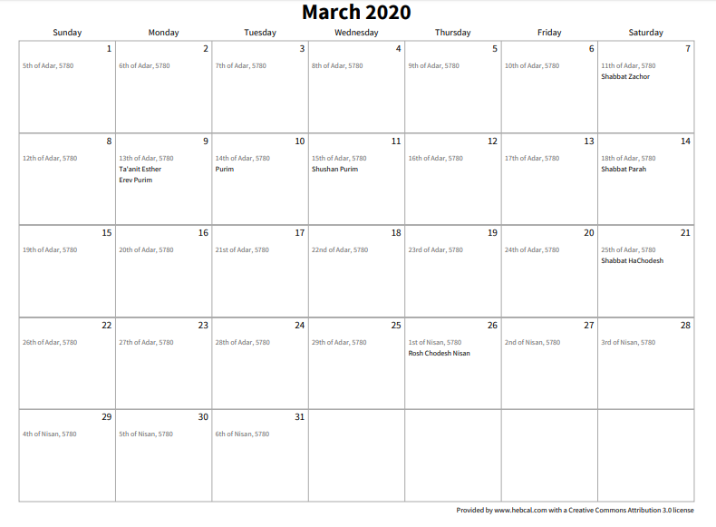
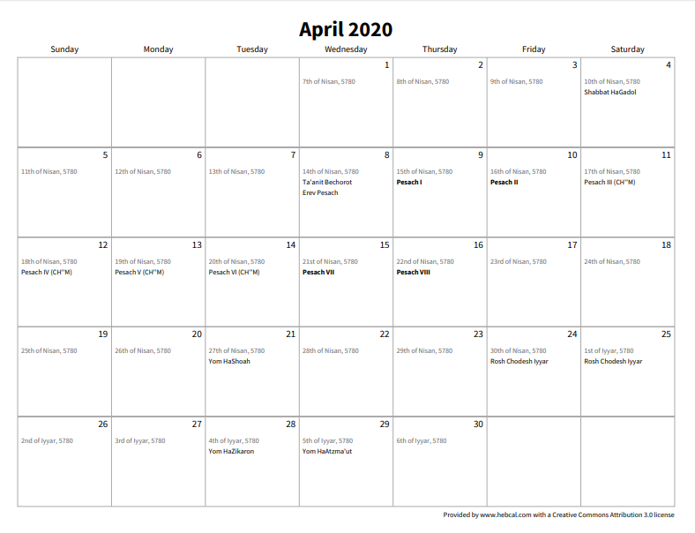

- FOR PRESCHOOLERS: Sort matzah from hametz (food that is leavened) sorting
Supplies: Two containers or trays, small pieces of matzah and hametz (bread, crackers, cake, cookies, etc).
  - Show your child examples of matzah (explain that this is a special food we eat on Pesah) and examples of hametz (explain that these are foods that many Jews do not eat on Pesah )
  - Help your child sort the matzah and hametz onto the two trays or containers.
  - Give your child an opportunity to do this on his or her own.

- FOR PRESCHOOLERS: Icy Karpas
Supplies: Ice cube trays, a variety of washed, fresh green herbs (parsley, basil, mint, etc), water, and a spoon
  - Tear the herbs into pieces that will fit into a section of the ice cube tray. Keep each variety separate.
  - Place one type of herb into each cube-holder/section. Add water and freeze.
  - Offer your child some lukewarm water, an ice cube and a spoon. Explain that karpas is a Hebrew word for vegetables that we eat on Pesah. Often (but not always) green, they represent new plants growing in spring.
  - Tell your child that in the ice cube is one kind of karpas. To be able to smell and eat it, s/he needs to stir the cube in the water until the ice melts. [You may need to change the water if it gets too cold.]
  - When the karpas is no longer in the frozen cube, give your child a chance to smell and eat it! Would s/he want to eat this at the Pesah seder?

FOR THINKERS
- I wish…
Supplies: Lots of creative materials
  - After reading or listening to Pesah book and having a family reminder-conversation about the holiday (“this is how we have celebrated it), challenge your child(ren) to make a decorated wish list:
    - For themselves during the holiday
    - For the family during the holiday
    - For those who left Egypt with Moses
    - For the Egyptians
  - Hang the lists up!

- Online fun and learning
  - ”I Left With Moses” (http://Ileftwithmoses.weebly.com) is a website for upper elementary age children, built around the big idea, "in every generation we have to see ourselves as if we left Egypt ..." There is are webpages with
    - Links and information for students http://ileftwithmoses.weebly.com/lets-do.html
    - Practice help for the seder http://ileftwithmoses.weebly.com/lets-practice.html
    - A page for parents http://ileftwithmoses.weebly.com/lets-learn.html
There's also a Facebook group for educators and parents with a couple uploads of scavenger-hunt type sheets (these need to be updated) that help students work on different areas of the site. (https://www.facebook.com/groups/948486035171133/)
  - Search and Share
    - Whip out those smartphones, set the timer for 5 or 10 minutes, ask an interesting question that would be hard just to Google an answer for, and let everyone search out whatever they can find while time ticks down. Award points for the most on-target answers. Question examples:
      - What is the hardest of the Four Questions to answer?
      - Which haroset recipe is the most popular? How do you know?
      - What changes to seder foods need to be made for people with eating choices or challenges: vegetarians, vegans, gluten-free, etc?
      - [FOR STRONG THINKERS] The haggadah says, “In every generation, we have to see ourselves as if we left Egypt.” Who, today (Jewish or not Jewish) acts as if s/he understands this statement?

- Asking questions
Make the PJ Library Pesah “fortune teller”(there is a version for preschoolers and a version for older children): https://pjlibrary.org/beyond-books/pjblog/march-2017/printable-pj-library-passover-question-catcher

SOME OTHER GREAT AT-HOME ACTIVITIES WE FOUND, ESPECIALLY FOR TEENS OR OLDER CHILDREN

- Family tour of the Israel Museum
  - Before “visiting,” make a list of at least 10 exhibits and pictures you might expect to see in the Israel Museum, located in Jerusalem.
  - Travel via this link: https://tinyurl.com/IsraelMuseumTour, click on the arrow at the bottom of the page to scroll through some exhibits.
  - Discuss:
    - How correct was your guess about the kinds of exhibits?
    - What do the exhibits tell you about the interests of Israelis?

- Movie Night
  - Adults and/or older teens
The Best Jewish TV and Movies to Watch on Netflix (geared for parents, not kids)
https://www.kveller.com/the-best-jewish-tv-and-movies-to-watch-on-netflix/

